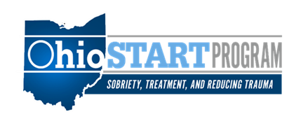
Ohio START Quarterly Coaching Call
April 2 & April 8, 2026
9:00 am – 10:00 am

Agenda

- Welcome

- Understanding and Mastering the Ohio START Timeline: Where Best Practice Meets Better Family Outcomes
Kathi Kurtz, Ohio START Northeast Regional Technical Assistance Consultant
Diana Hoover, Ohio START Northwest Regional Technical Assistance Consultant
Jen McClellan, Evaluation and Performance Manager

- Questions

- Next Coaching Call: July 8 & 9, 2026, at 9:00 am

