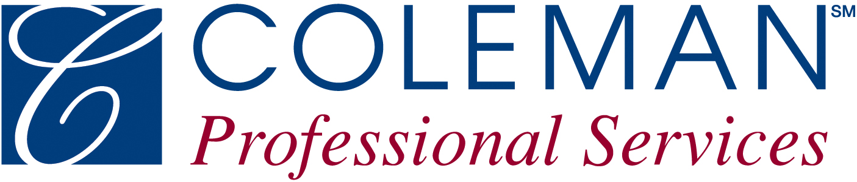
5982 Rhodes Road
Kent, OH 44240

330-673-1347
800-673-1347
Fax: 330-678-3677

JOB OPENING

PLEASE POST

FAMILY PEER MENTOR
FULL TIME
HARDIN COUNTY

Coleman Professional Services, a nationally recognized not-for-profit provider of behavioral health and rehabilitation programs is seeking two Family Peer Mentors to partner with Department of Job and Family Services and their Ohio START Program in hARDIN County, Ohio. The overall goal of this program is to stabilize families harmed by parental drug use so that both children and their parents can recover and move forward with abuse-free and addiction-free lives. Ohio START integrates community partners to ensure the seamless provision of wraparound services.

Key Components of the Ohio START Model include, but not limited to:
- Cross-system collaboration with county public children services agencies (PCSA), behavioral health providers, courts, and other community partners, dedicated to building community capacity and making Ohio START work

- Family-centered approach that fosters integrated systems-of-care between the PCSA, behavioral health providers and the courts by addressing differences in professional perspectives

- A specialized children services worker and Family Peer Mentor dyad serve families with co-occurring substance use and child maltreatment

- The Family Peer Mentor brings real-life experience to the team and is a person in long term recovery with previous children services involvement. Family Peer Mentors are rigorously screened, trained and supervised to provide Ohio START families with both recovery coaching and help navigating the PCSA system

- Child-focused services to promote attachment, reduce the effects of trauma, and provide developmental supports

- Evaluation to create a learning culture and identify opportunities to improve fidelity and family-centered outcomes

Must have experience with behavioral health disorders, especially substance use disorder; navigating systems of behavioral healthcare; navigating community resource systems; willingness to collaborate care with Department of Job & Family Services and other involved care providers; ability to attend regular meetings for staff development and client care; strong communication skills; and willingness to share lived Children Services experience with consumers. Must be in the process of obtaining certification through the Ohio Department of Mental Health and Addiction Services for Peer Recovery Supporter and have/maintain excellent driving record. Must have or be willing to obtain a NPI number and an Ohio Medicaid number. Preferred qualifications include having a lived experience with the child welfare system either as a parent or child, with the case closed at least one year. If you do not have direct CPS experience, you must be able to describe how your substance use affected your children and family.

Benefits options include health, life, pension, paid time off, and more. Qualified applicants will receive consideration for employment without regard to race, color, religion, sex, national origin, sexual orientation, gender identity, disability or protected veteran status. E.O.E. Persons with a disability can request an accommodation to complete the application process by emailing careers@colemanservices.org with the subject line “Accommodation Request.”

If interested in applying for this position, visit the e3 Home Page. On the right side under the “External Links” section select “Current Job Openings” and then select the blue icon to “Search Open Jobs” or select Career Opportunities along the top.

*ALSO NOTIFY THE HR GENERALIST BELOW
THAT YOU ARE APPLYING FOR THIS POSITION*

For questions contact Jennifer Souders, HR&C Specialist
Email: jennifer.souders@colemanservices.org
Phone: 567-356-4404

Posting Date: October 14th, 2020

